**How to tidy up Space Reservation so that Occupancy is Accurate**

1. Run the Scheduling Edit Report to give you an idea of which Contracts require the Space Reservation to be tidied. To access the report go to Reports > Charting > Scheduling Edit.
2. If you have not been doing tidying regularly, then you will need to run it for a large date range.

Enter all your filters and reminder to exclude Production and Install Segment Status’

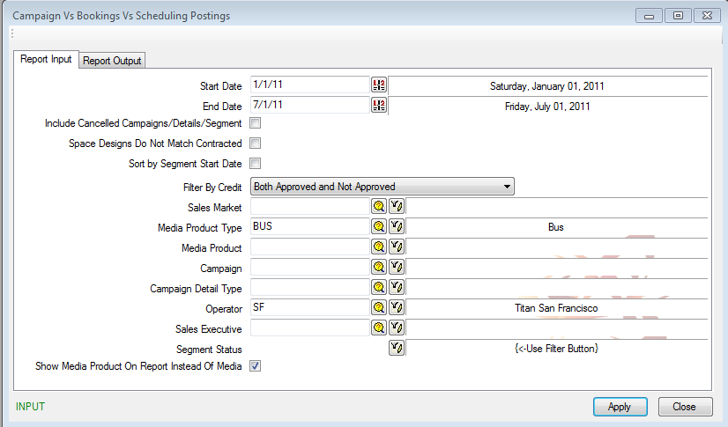

1. Go to the report Output tab and use the Output to grid option so you can export the report to excel.

Quick reminder of the definitions of the fields on the Scheduling Edit report

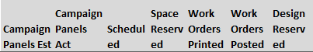

**Campaign Panels Est** – Count of Panels Contracted

**Campaign Panels ACT** – Count of Panels Charted/Booked

**Scheduled** – Designs assigned to charted panels – need to do this to send out work orders

**Space Reserved** – Is space being reserved.  If panels are charted then space does not need to be reserved.  It’s either or.

**Work Orders Printed** – Count of Work Orders Printed

**Work Orders Posted** – Count of Panels be input as “installed” back into Quattro

**Design Reserved** – For Buses and Interiors only. Count of designs assigned to the Space Reserved in the various garages.

1. If it is not important to tidy up Space reservation for months that have passed, then Sort the Segment End Date column so you can delete all segments/rows that have already ended. However, doing this means that Occupancy for past months will not be accurate.
2. Once you have your list of contracts, you need to make sure that **if** the “Campaign Panels ACT” column is equal to or greater than the “Campaign Panels EST” column, then Space Reservation should be 0. If it is not 0, then you need to go into that contract and delete Space Reservation.

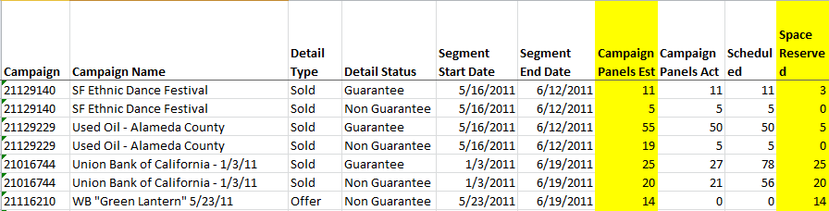

Using the Segments above as examples, below would be the course of action.

Contract # 21129140 - Campaign Panels ACT = 11

Campaign Panels EST = 11

Space Reserved = 3

Course of Action > Delete the Space Reservation for 3 as this Campaign has been fulfilled.

Contract # 21129140 - Campaign Panels ACT = 5

Campaign Panels EST = 5

Space Reserved = 0

Course of Action > None. This is now a completed campaign should look

Contract # 21129229 - Campaign Panels ACT = 50

Campaign Panels EST = 55

Space Reserved = 5

Course of Action > None. The install is in progress. 5 more still have to be installed.

Contract # 21129229 - Campaign Panels ACT = 5

Campaign Panels EST = 19

Space Reserved = 0

Course of Action > None. This is a Based on Space Segment, looks like Space Reservation was never reserved for it.

Contract # 21016744 - Campaign Panels ACT = 27

Campaign Panels EST = 25

Space Reserved = 25

Course of Action > Delete the Space Reservation for 25 as this Campaign has been fulfilled. This campaign is double reserving, therefore overestimating Occupancy.

Contract # 21016744 - Campaign Panels ACT = 21

Campaign Panels EST = 20

Space Reserved = 20

Course of Action > Delete the Space Reservation for 20 as this Campaign has been fulfilled. This campaign is double reserving, therefore overestimating Occupancy.

Contract # 21116210 - Campaign Panels ACT = 0

Campaign Panels EST = 14

Space Reserved = 14

Course of Action > None. This is still an offer that has space reserved. Probably awaiting the signed contract to come it. If this is an expired hold, then Space Reservation should be deleted as it is reserving 14 spaces.

**How to delete Space Reservation**

1. Go to the contract and find the segment that is over-reserving space. In example # 1 for Contract # 21129140, you can tell which segment it is, because in the Campaign Segments grid it shows the same columns as it does in the Scheduling Edit report.

ACT Panels = 11

Estimated Panels = 11

Space Reserved = 3

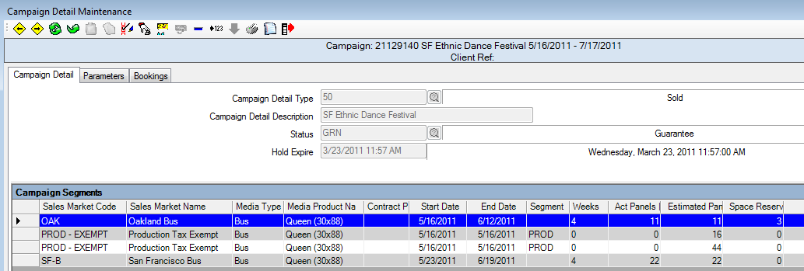

1. Double click on the Oakland Bus segment and go to the Space Reservation button. From the Space Reservation screen itself, you can see that the Total Reserved Value is red. This is to indicate that you have exceeded your Estimated Panels on the Segment.

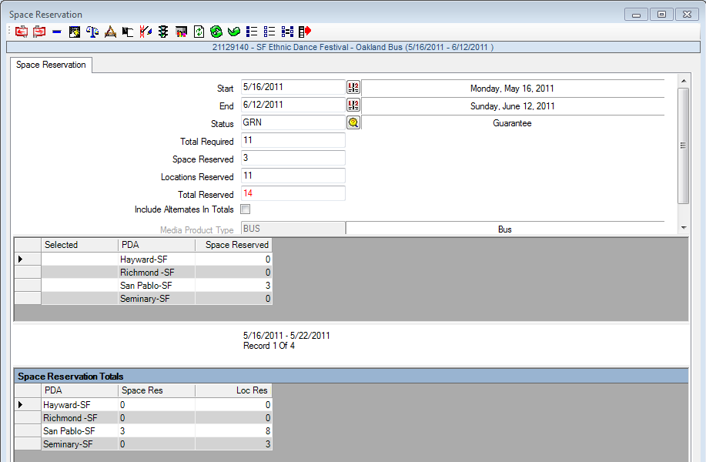

1. To delete the extra Space Reserved, click on the “Clear All Space Reservation” button. In doing so, the value in the Space Reservation field, goes to zero, and the Total Reserved now goes to 11 and is no longer red.

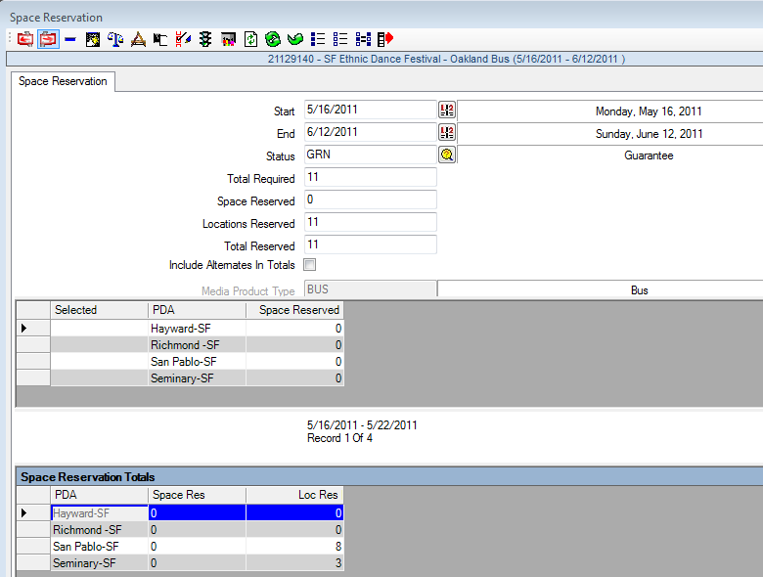

**\*\*\*\*Common Reasons for Over-Reservation**

1. Installations into the garages differ from the space reserved.

Example: 50 Kings to be installed

**Space Reservation:**  **Installations**

(25) Garage A (30) Garage A

(25) Garage B (20) Garage B

Over-Reservation of 5

1. Schedule Dates used on the Change Out screen do not match the Segment Dates.

Example: 50 Kings to be installed 7/1/11 – 7/31/11 (segment Dates)

If you shift the Scheduled Dates on the Change Out screen to anything but 7/1/11, the Panels installed will not be removed from Space Reservation.

**Space Reservation:**  **Installations**

(25) Garage A (10) Garage A Scheduled Date 7/1/11

(20) Garage A Scheduled Date 7/15/11

(25) Garage B (20) Garage B Scheduled Date 7/1/11

Over-Reservation of 20